**Sudha Amarnath**



**Graduate and Extended Studies**

**FA19: CMPE-297 Sec 01 - Special Topics**

**Prof. Chandrasekar Vuppalapati**

1. **MQTT AWS IoT PUB SUB MODEL**

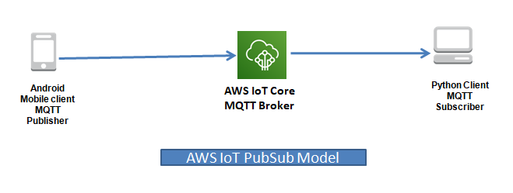

1. Android App is used to run AsyncTask generating Temperature, Humidity and Activity ID and is sent to AWS IOT topic “mqttPubSubAwsTopic’’.
2. Configuring AWS IOT core as MQTT Broker.
3. Python Client is the MQTT subscriber for Topic “mqttPubSubAwsTopic’’.
4. **Video Demo**

The demo video shows the generated sensor values from the Android App is published to the AWS IOT MQTT Broker. In the command prompt the Python subscriber client is executed which receives the messages subscribed for the same topic. Please refer the video link below.



1. **Screenshot of Android MainActivity – Topic name highlighted**

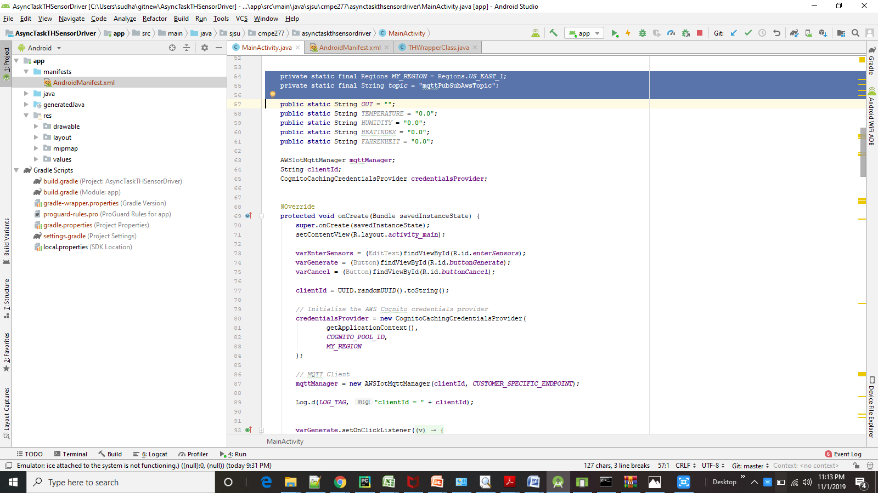

1. **Generating 1 Sensor Output from Mobile Client**

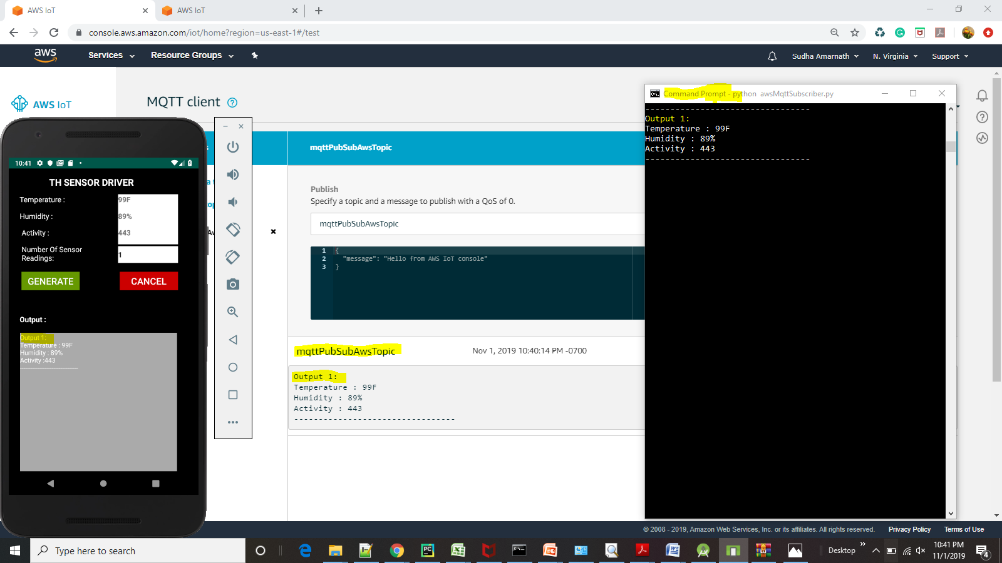

1. **Generating 3 Sensor Output from Mobile Client**

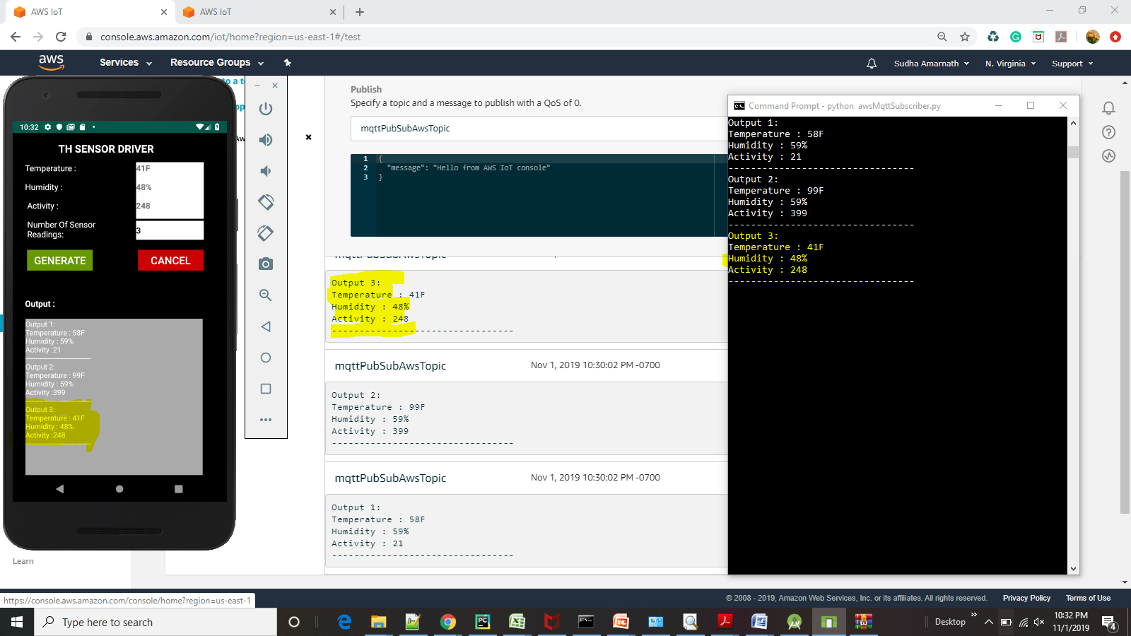

1. **Generating 8 Sensor Output from Mobile Client**

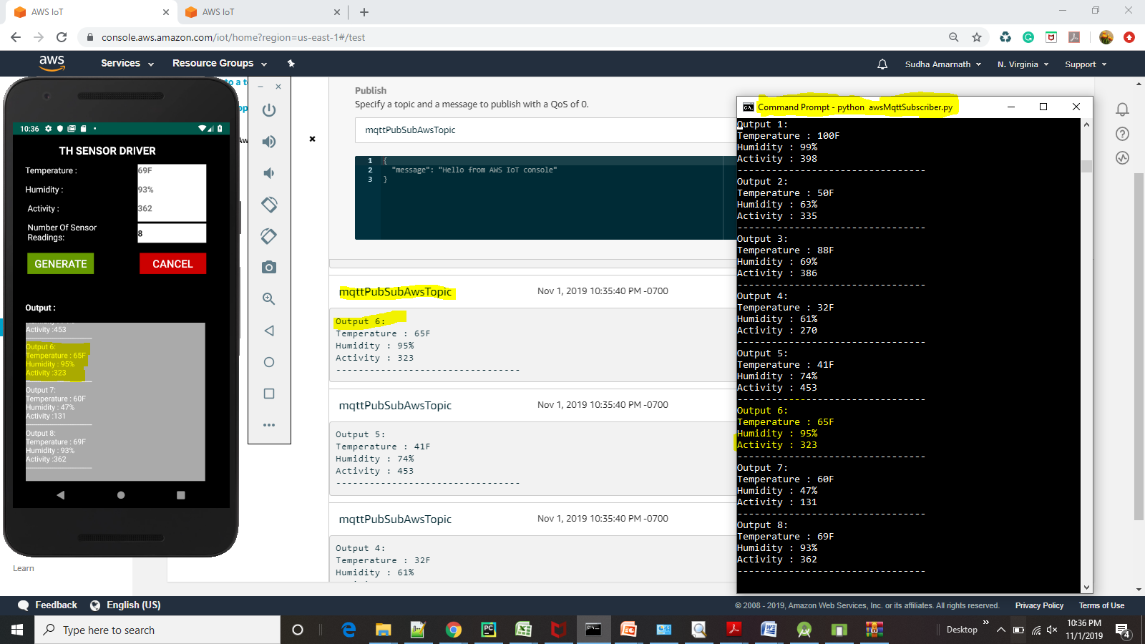

1. **Generating 20 Sensor Output from Mobile Client**

